- Purpose

The purpose of this procedure is to put into detail how to properly start and stop the main MgO mix pot, located on top of digester #4.

- Scope

This procedure applies to the main MgO mix pot located on top of digester #4.

- Responsibility

Lead Operators, Process Operators

- Safety Considerations

Safety shoes and safety glasses are required when working in, on, or around the digesters. Sulfuric acid is highly corrosive to clothing and the human body. If you come into contact with it, immediately flush the affected area(s) with water for 10 minutes.

Safety is a condition of employment. Employees are not authorized to work in an unsafe manner and are prohibited from harming the environment of the facility or community.

- Materials/Equipment

- Monitoring System

- Procedure

NOTE: The Main MgO Mix Pot must be started separately, and before, Digester #4 is started. Digesters 1, 2 and 3 have their own mix pots. Their operation is not tied to the Main MgO Mix Pot described in this procedure.

Starting the Main MgO Mix Pot:

  - Ensure that all hand valves, except for the bottom drain, are open.
  - Ensure that the bottom drain is closed.
  - From the Digester Area screen in the Monitoring System, click the ‘Mix Pot’ button:
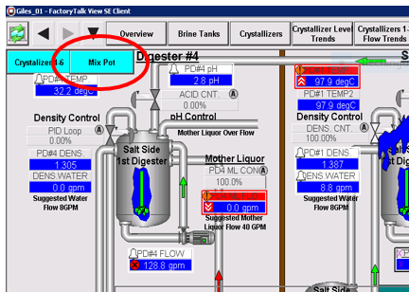
  - It will bring up this screen
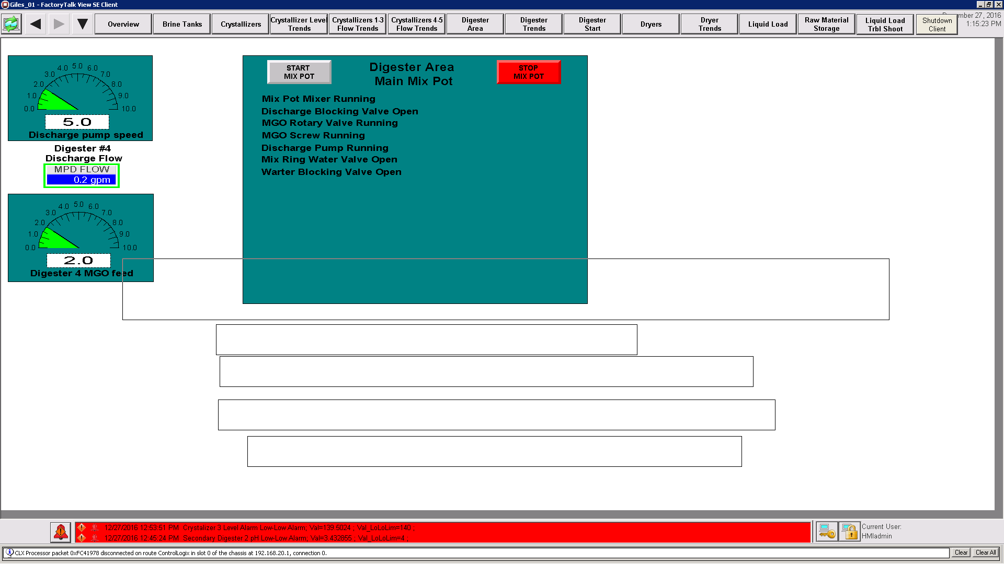
  - Press the ‘Start Mix Pot’ button to begin operations.

NOTE: The Main MgO Mix Pot can be started from empty or partially full using the above procedure.

Stopping the Main MgO Mix Pot:

  - Ensure that all hand valves, except for the bottom drain, are open.
  - Ensure that the bottom drain is closed.
  - From the Digester Area screen in the Monitoring System, click the ‘Mix Pot’ button:
  - It will bring up this screen
  - Press the’Stop Mix Pot’ button to end operations.

- Reference Documents

None

- Change Information

Document review:
- New document

